PRACTICE PROBLEMS

1. **CREATE DATABASE IN MONGODB.**

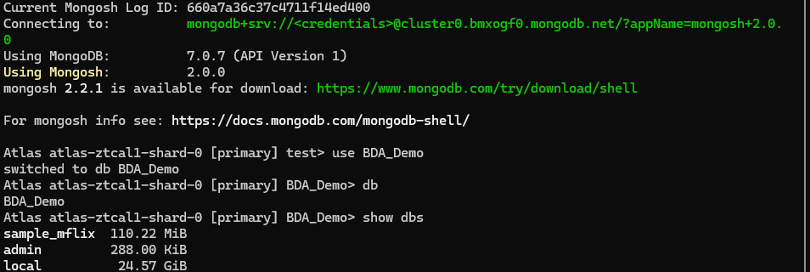

1. **CRUD (CREATE, READ, UPDATE, DELETE) OPERATIONS**
2. To create a collection by the name “Student”. Let us take a look at the collection list prior to the creation of the new collection “Student”.



2.To drop a collection by the name “Student”.





